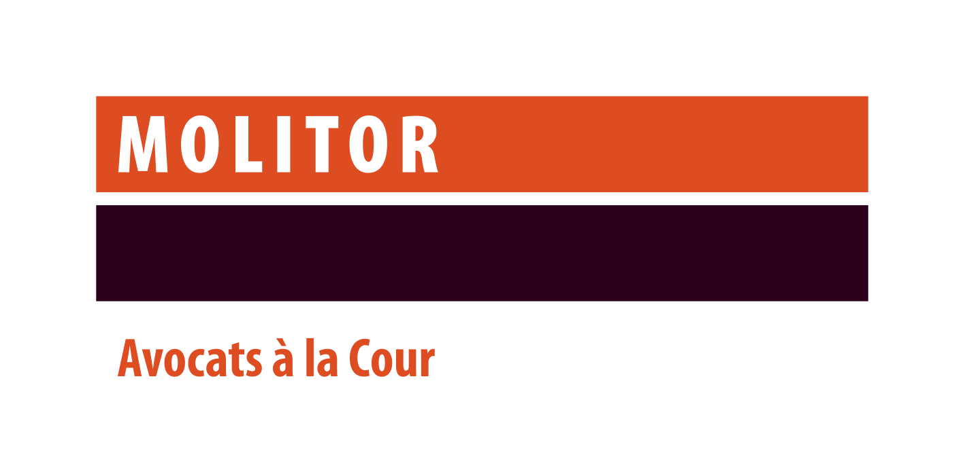

Associate Lawyer for our Employment Practice
Contact: Sophie Icher - sophie.icher@molitorlegal.lu

Your mission
Assisting our clients in a variety of employment matters including:
- Individual employment relationships (assisting employers with employment contracts, internal rules and policies, flexibility of work, management of inability to work, pensions, social security, termination of employment, poaching, etc.);
- Collective employment law (assisting our clients with the amendment or drafting of collective bargaining agreements, relations with their staff representatives, relation with the ITM, social plans, employment safeguard plans,);
- Labour litigation & dispute resolution (negotiation of out-of-court agreements, proceedings in front of the Labour Court, the Administrative Courts or the Social Security Courts, etc.);
- International mobility of employees (secondment within a group, teleworking, including immigration and social security related issues, etc.).
You will also assist other department of the firm from time to time, notably our M&A department regarding the employment law aspects of acquisitions (due diligences, SPA, transfer of undertaking, etc.)
You will primarily be advising our clients on the above matters, but also assisting them in front of the courts in judicial proceedings.
Your profile
- Member of the Luxembourg Bar;
- University degree in law completed by a post-graduate degree;
- At least 2 years’ experience in a recognized law firm in Luxembourg and a solid background in Luxembourg labour law;
- Personal communications skills;
- Excellent written communication and drafting skills;
- Fluent (written and spoken) in both French and English. Proficiency in Luxembourgish and German would be highly appreciated;
- Team player and client oriented.

Our values:

We have a strong focus on how we recruit, train and reward our staff and always ensure that they are fully aligned with our work culture built around our four core values:
- Service Excellence - We seek to exceed our clients’ expectations, through impeccable quality advice and deliverables.
- Integrity & Trust - We ‘walk the talk’ – Being widely trusted by all our counterparts is essential to us.
- Teamwork – We place team goals above individual goals
- Approachability – Building rapport with all our counterparts is a key priority for us.

About the firm:

We are a top independent law firm based in Luxembourg with a wide international network. Local and international clients rely on us for our recognised expertise in legal matters and disputes involving Luxembourg law. We pride ourselves in being a multidisciplinary firm serving all major sectors of the economy.

